

**Minutes of the 02/19/2013 IEEE Tampa Bay RAS Meeting**

(Prepared by Sean Denny, Recording Secretary)

Location: MOSI at 4801 E Fowler Avenue, Tampa, FL, 33617

Room: Idea Zone Maker Space

Date: February 19, 2013

Time: 6:35pm to 7:40pm

The Tampa Bay Chapter of IEEE’s Robotics and Automation Society held the February meeting at The Museum of Science and Industry in Tampa. The IEEE RAS Chapter plans to execute on the Vision of the Chapter’s Founder, George Schott to “Learn, Do, Teach”.

There were a total of 12 people made of 4 IEEE members, 2 Students, and 6 guests present.

OFFICER ROLL CALL:

o Chairman – Ken Fiallos

o Vice-Chairman/Secretary – Sean Denny

o Treasurer – Tom Hayden

ANNOUNCEMENTS:

2/22-TBEWB Engineering Banquet at A La Carte Banquet Hall

2/22-2/23 Engineering Expo at USF

Eastlake Public Library under Jim Kendall, [jkendal2@tampabay.rr.com](mailto:jkendal2@tampabay.rr.com), Lead Robotic Mentor.

3/16/13-Robofest in Oldsmar—Emma Alaba requests mentors and judges.

3/20/13-HCC Brandon BEST Introductory Workshop in place of the RAS March Meeting. Workshop lasts from 4-7pm. Three PDHs are awarded that evening.

3/30/13-Arduino ABC Workshop at DeVry University.

PRESENTATION:

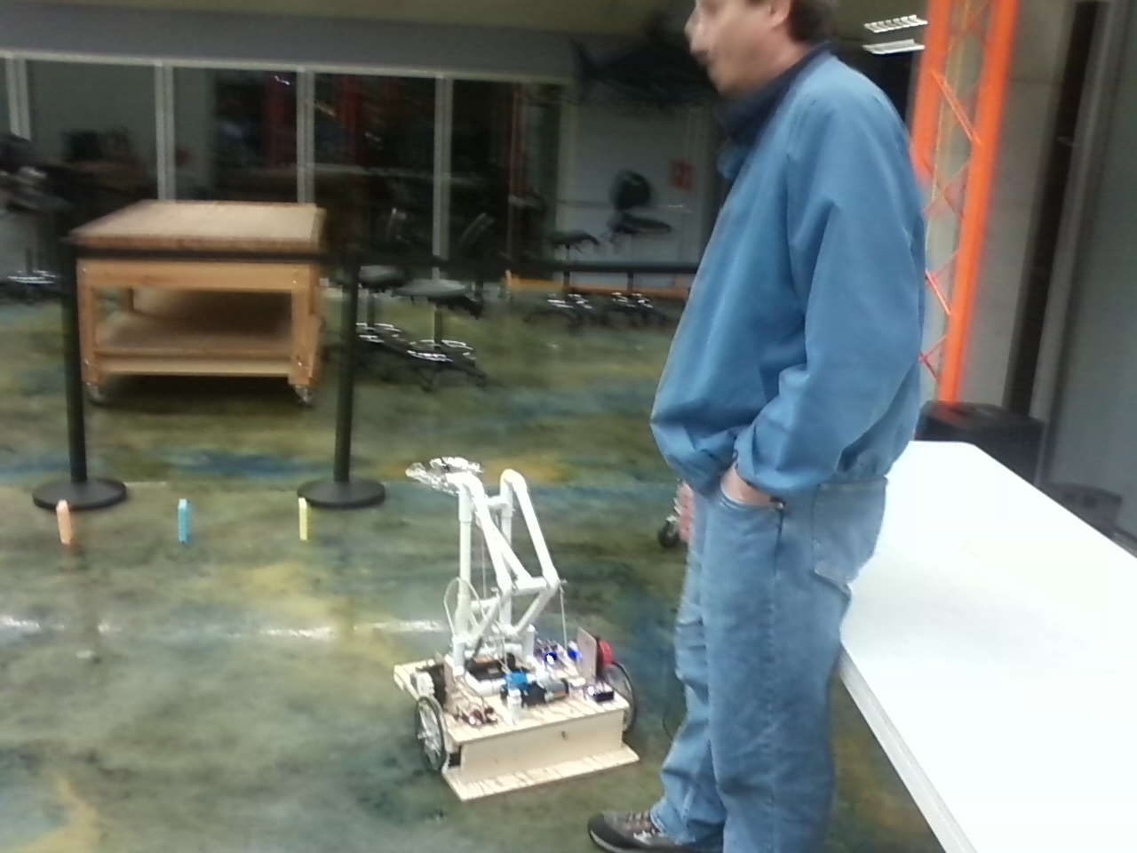

Tom Hayden led a demonstration on a BEST robot prototype using the 80211g Vex Controller. He used Robot C and Easy C to program the robot. The attendees accepted challenges of controlling with a remote to make the robot pick up sponges and move them to a chair.

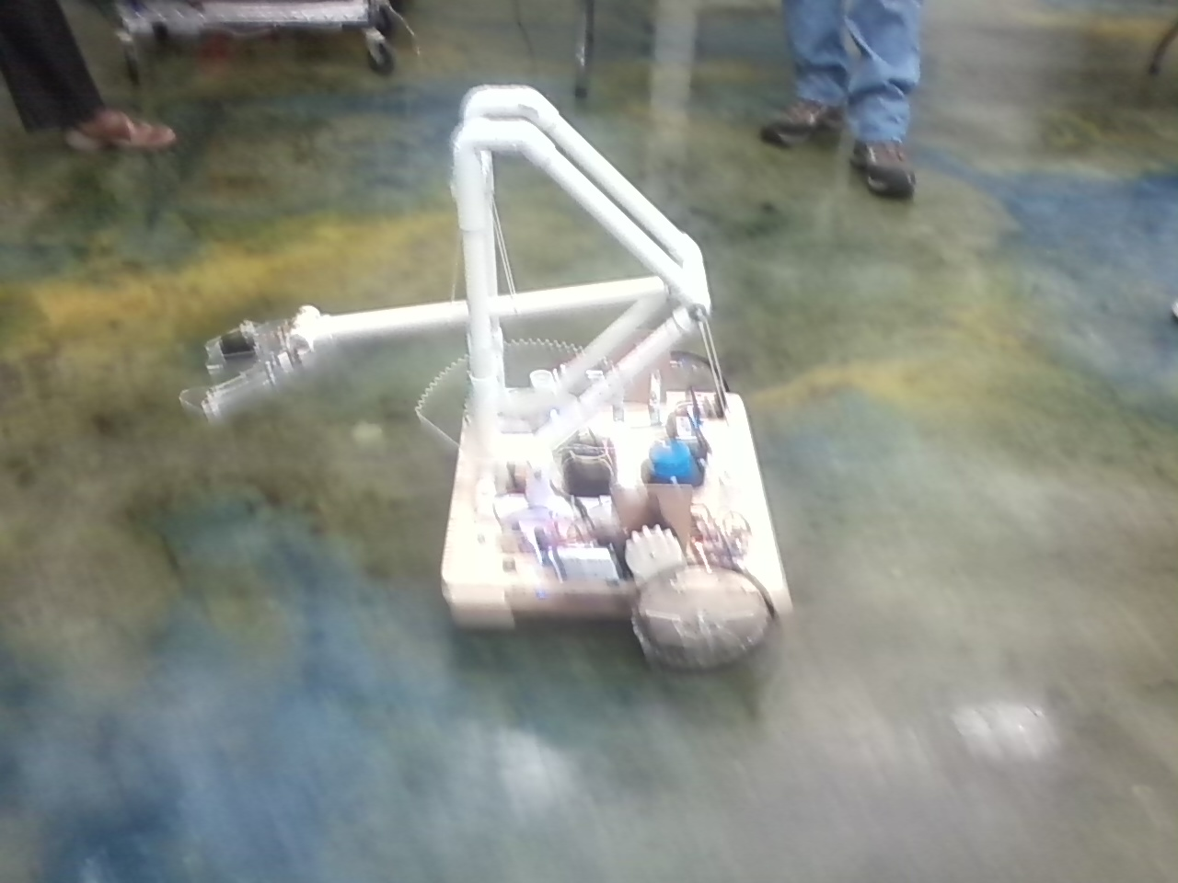

OLD BUSINESS:

The Motion to approve the January Minutes as published was made by Bill Wagoneer. Seconded by Tom Hayden. There was no discussion and the motion passed unanimously.

NEW BUSINESS:

Jim Melton resigned as treasurer because he took an employment opportunity out of state. Tom Hayden agreed to be a nominee for Treasurer. Sean Denny motioned to accept the nomination and elect Tom Hayden as RAS Chapter Treasurer; Seconded by Bill Wagoneer.

Ken Fiallos applied for the USF Federal Credit Union Account because it is a safe place to store the money and there are no monthly charges. Bill Wagoneer motioned that the board officers of the FL Robotic Alliance who signed the application would be authorized to vote; Seconded by Sean Denny.

Ken announced the Steering Committee for the FL Robotic Alliance need to meet on March 6, 2013 at 6pm.

Adjourned at 7:40pm by Ken Fiallos; Seconded by Sean Denny

Respectfully submitted by

Sean Denny,

Tampa Bay IEEE RAS Chapter Secretary

[venner20@ieee.org](mailto:venner20@ieee.org)

727-678-0183